Gap Analysis:
Assessment & Management of Pain, Third Edition, Revised 2013

Work Sheet

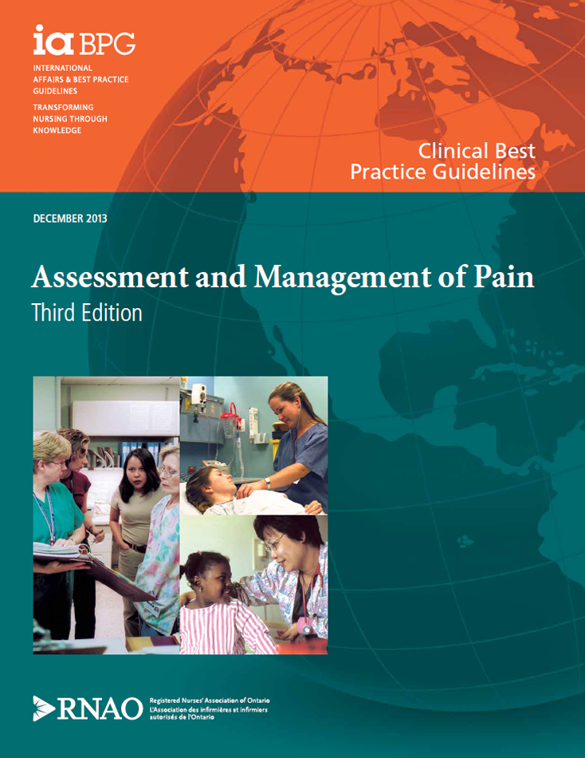
This guideline can be downloaded for free at:
http://rnao.ca/bpg/guidelines/assessment-and-management-pain

The RNAO Leading Change Toolkit 3rd Edition
https://rnao.ca/leading-change-toolkit

Date Completed:
Team Members participating in the Gap Analysis:

Completion of this gap analysis allows for the annual comparison of your current practice to evidence-based practices as regulated by the MOHLTC per Fixing Long-Term Care Act, 2021 at https://www.ontario.ca/laws/statute/21f39 &
O. Reg. 246/22: GENERAL (ontario.ca)

RNAO Best Practice Guideline Recommendations | Met | Partially Met | Unmet | Notes  (Examples of what to include: is this a priority to our home, information on current practice, possible overlap with other programs or partners)
Practice Recommendations: Assessment
1.1 Screen for the presence, or risk of, any type of pain:
- On admission or visit with a health-care professional;
- After a change in medical status; and
- Prior to, during and after a procedure
(Level Ib Evidence)
1.2 Perform a comprehensive pain assessment on persons screened having the presence, or risk of, any type of pain using a systematic approach and appropriate, validated tools
(Level Ib Evidence)
1.3 Perform a comprehensive pain assessment on persons unable to self-report using a validated tool.
(Level III Evidence)
1.4 Explore the person’s beliefs, knowledge and level of understanding about pain and pain management.
(Level of Evidence = III)
1.5 Document the person’s pain characteristics.
(Level IIa Evidence)
Practice Recommendations: Planning
2.1Collaborate with the person to identify their goals for pain management and suitable strategies to ensure a comprehensive approach to the plan of care.
(Level Ib Evidence)
2.2 Establish a comprehensive plan of care that incorporates the goals of the person and the interprofessional team and addresses:
- Assessment findings;
- The person’s beliefs and knowledge and level of understanding; and
- The person’s attributes and pain characteristics
(Level III Evidence)
Practice Recommendations: Implementation
3.1 Implement the pain management plan using principles that maximize efficacy and minimize the adverse effects of pharmacological interventions including:
- Multimodal analgesic approach;
- Changing of opioids (dose or routes) when necessary;
- Prevention, assessment and management of adverse effects during the administration of opioid analgesics; and
- Prevention, assessment and management of opioid risk
(Level Ib Evidence)
3.2 Evaluate any non-pharmacological (physical and psychological) interventions for effectiveness and the potential for interactions with pharmacological interventions.
(Level Ib Evidence)
3.3 Teach the person, their family and caregivers about the pain management strategies in their plan of care and address known concerns and misbeliefs.
(Level Ib Evidence)
Practice Recommendations: Evaluation
4.1 Reassess the person’s response to the pain management interventions consistently using the same re-evaluation tool. The frequency of reassessments will be determined by:
- Presence of pain;
- Pain intensity;
- Stability of the person’s medical condition;
- Type of pain e.g. acute versus persistent; and
- Practice setting
(Level IIb Evidence)
4.2 Communicate and document the person’s responses to the pain management plan.
(Level IIb Evidence)

Education Recommendations
5.1 Educational institutions should incorporate this guideline, Assessment and Management of Pain (3rd ed .), into basic and interprofessional curricula for registered nurses, registered practical nurses and doctor of medicine programs to promote evidence-based practice.
(Level IIb Evidence)
5.2 Incorporate content on knowledge translation strategies into education programs for health-care providers to move evidence related to the assessment and management of pain into practice.
(Level IIb Evidence)
5.3 Promote interprofessional education and collaboration related to the assessment and management of pain in academic institutions.
(Level Ib Evidence)
5.4 Health-care professionals should participate in continuing education opportunities to enhance specific knowledge and skills to competently assess and manage pain, based on this guideline, Assessment and Management of Pain (3rd ed.).
(Level IV Evidence)
Organization and Policy Recommendations
6.1 Establish pain assessment and management as a strategic clinical priority.
(Level IV Evidence)

6.2 Establish a model of care to support interprofessional collaboration for the effective assessment and management of pain.
(Level IIb Evidence)
6.3 Use the knowledge translation process and multifaceted strategies within organizations to assist health-care providers to use the best evidence on assessing and managing pain in practice.
(Level III Evidence)
6.4 Use a systematic organization-wide approach to implement Assessment and Management of Pain (3rd ed.) best practice guideline and provide resources and organizational and administrative supports to facilitate uptake.
(Level IV Evidence)

